This is the stage rider for Trolds concerts.
Input List

Ch | Source | Mic | +48V | Note
1 | BD in | D6/e602
2 | BD out | D6/e602
3 | SN top | sm57
4 | SN bottom | sm57
5 | Hi-hat | cond | X
6 | Tom 1 | D2
7 | Tom 2 | D2
8 | Tom3 | D2
9 | Ride | cond | X
10 | OH L | cond | X
11 | OH R | cond | X
12 | Gtr stage R |  |  | Patchbay on front of rack
13 | Bas |  |  | Patchbay on front of rack
14 | Gtr stage L |  |  | Patchbay on front of rack
15 | VOX stage R | XLR |  | Patchbay on front of rack  Venue supplies mic, stand and xlr-xlr cable  Mic is patched on the front of rack
16 | VOX stage C | XLR |  | Patchbay on front of rack  Trold brings own wireless mic.  Mic is patched on the front of rack
17 | VOX stage L | XLR |  | Patchbay on front of rack  Venue supplies mic, stand and xlr-xlr cable  Mic is patched on the front of rack
18 | VOX Drums |  |  | Patchbay on front of rack  Venue supplies mic, stand and xlr-xlr cable  Mic is patched on the front of rack
19 | Back track L |  |  | Patchbay on backside of rack
20 | Back track R |  |  | Patchbay on backside of rack

Stage plot
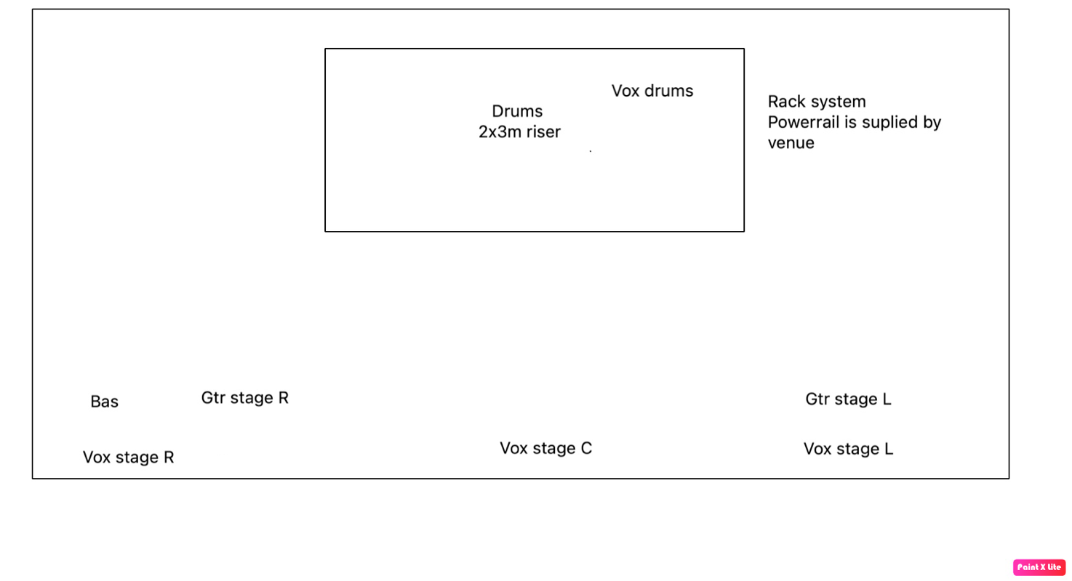

Stage
Minimum 8x5m stage, 80 cm tall, free of cables, confetti and other debris when changeover begins.

IMPORTANT NOTE: Band members will be performing bare foot, it is therefore an absolute must that there is no broken glass, leftover screws or other sharp debris on stage at the beginning of changeover. This also includes any gravel or pebbles.
If the stage is modular, please ensure that all bolts are tightened before changeover so that no one gets their bare feet stuck in a crack.
Lights
Please supply professional lighting setup, minimum smoke, plain front lights, colored rear lights. Trold does not bring a lighting engineer, so please supply a skilled person to control the lights during the show. Please do not turn off the lights entirely between songs, so we can’t find our way around the stage. We will bring a backdrop, 4x2.5m, please make sure it’s lit. The backdrop is quite colorful, so white light is preferred. Also, please make sure to not only light the drums, but also the drummer.

Monitors
Trold is bringing their own in ear rack system, so no monitors on stage are needed.

Backline
In case, Trold does not supply backline, the following will be required.
One drumkit of professional quality with drumheads in decent shape preferred, including:
- One (1) kickdrum, 22” preferred.
- Four (4) toms, 8”, 10”, 12” rack and 16” floor preferred.
- One (1) back-up 14” snare drum with fresh head. 14”x6,5” preferred
- Seven (7) cymbal stands, minimum 3 straight and 4 attachable booms with clamps. Can bring if needed. Please advise in that case.
- One (1) Hi-hat-stand.
- One (1) snare stand
- One (1) sturdy drum throne. Must have a spindle, and under no circumstances a telescopic pipe. Minimum 60 cm tall.
- Fan
Will bring: Snare, bassdrum pedal, all cymbals, cow bell.
Contact
General: Allan Madsen +45 26296537, troldemetal@gmail.com
Technical/backline: Christian Christiansen +45 20857077

We are looking forward to playing the show at your venue and we hope these requirements can be met in full. In case of any issues, please do not hesitate to contact the band or crew. We can find a solution to any issue, and we are open to changes or compromise as long as it is settled before the day of the show. We do not, however, like surprises.

